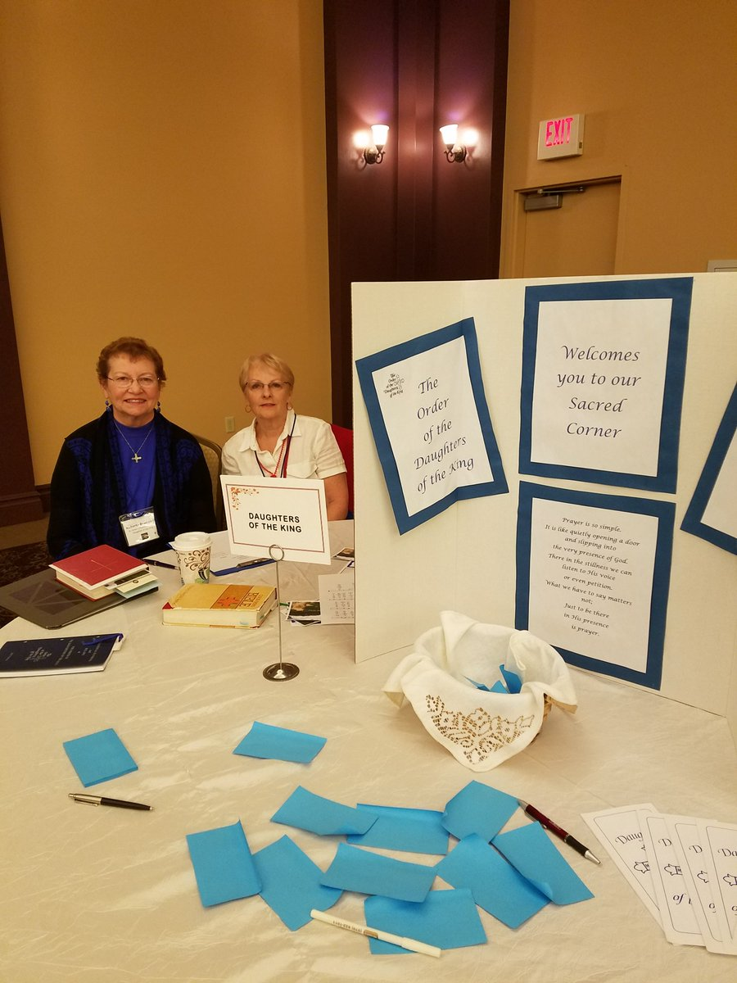

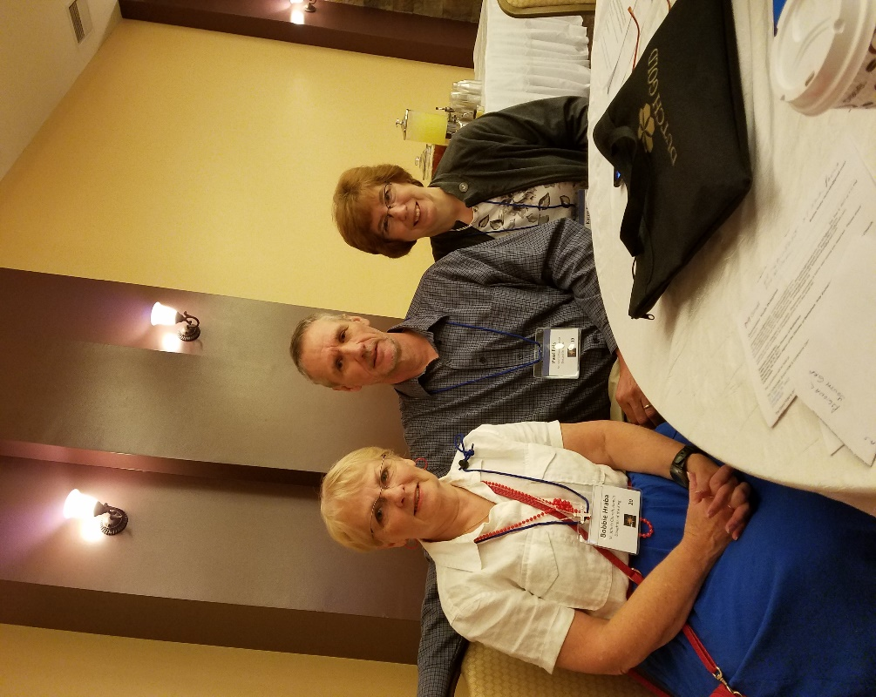

Our 146th Diocesan Convention held September 29-30, 2017

Roberta Brandreth is the President of the Diocesan Daughters of the King. (pictured on left)
Bobbie Hraba is the President of the local chapter Mary, the Lord's Mother of the Daughters of the King. (Pictured on right)

We were "manning" the booth for the Daughters where we were accepting prayer requests. These requests will be prayed for at our next Assembly in Bethlehem on SAT, 14 OCT.

Bobbie Hraba, Paul and Karen Fels at our 146th Diocesan Convention held September 29-30, 2017
held at the Carbondale Grand Hotel & Conference Center.

